Homework 6 – Cities

Jamie Gashler – Java Programming I

* It is important to override class Object in our code because it allows us to define behaviors that are specific to that subclass type. It prevents errors and allows the user to implement parent classes based on its requirements.
* The difference between overloading and overriding is that overloading happens when multiple methods in one class have the same method name, but contain different parameters, whereas overriding occurs when there are two methods with the same name and method signature. Overriding requires parent and child classes, while overloaded classes do not.
* The relationship between the hashCode() and equals() in java are that if two objects are equal according to the equals() method, then the hashCode() method should return the same integer value for both objects. They have a contract where it is generally necessary to override the hashCode() method whenever the equals() method is overridden.

**Entering City Name:**

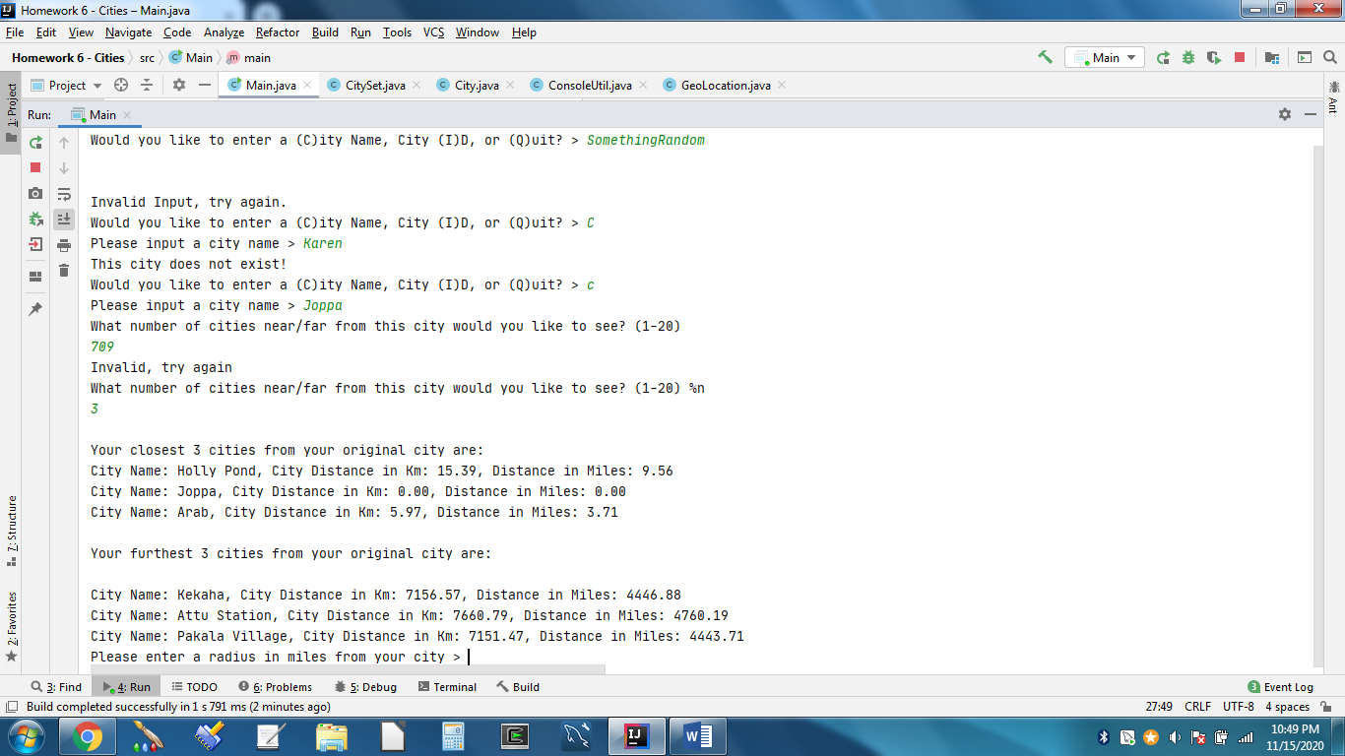

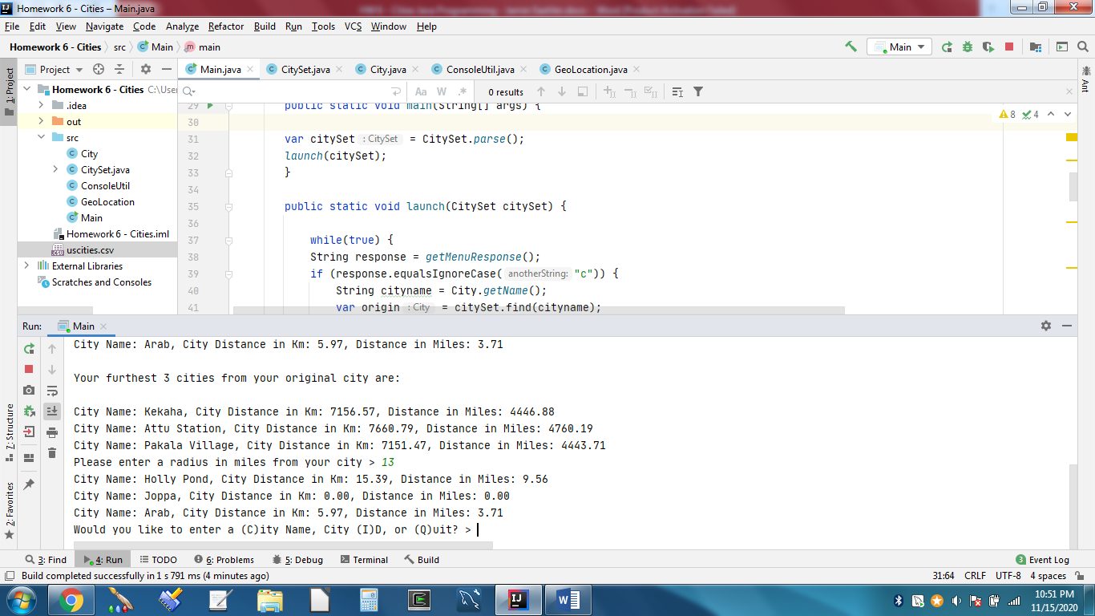

**Entering City ID:**





**Exiting the program:**

